***Business Analytics, 2e, GE* (Evans)**

**Chapter 16 Decision Analysis**

1) A(n) ________ is a matrix whose rows correspond to decisions and whose columns correspond to events.

A) decision tree model

B) payoff table

C) utility function table

D) scoring model

Answer: B

Diff: 1

Blooms: Remember

Topic: Making Decisions with Uncertain Information

LO1: Construct a payoff table for a decision situation.

LO2: Describe the major tools and criteria for decision making.

Use the information below to answer the following question(s).

Below is a payoff table that lists four mortgage options:

|  |  |  |  |
| --- | --- | --- | --- |
|  | **Outcome** | | |
| **Decision** | **Rates Rise** | **Rates Stable** | **Rates Fall** |
| **1-year ARM** | $66,645 | $43,650 | $38,560 |
| **3-year ARM** | $62,857 | $47,698 | $42,726 |
| **5-year ARM** | $55,895 | $50,894 | $48,134 |
| **30-year fixed** | $52,276 | $52,276 | $52,276 |

2) What is the average payoff for the 3-year ARM?

A) $ 52,792

B) $ 45,212

C) $ 51,094

D) $ 55,278

Answer: C

Diff: 1

Blooms: Apply

AACSB: Analytic Skills

Topic: Making Decisions with Uncertain Information

LO1: Apply average, aggressive, conservative, and opportunity-loss decision strategies for problems involving minimization and maximization objectives.

LO2: Describe the major tools and criteria for decision making.

3) What is the average payoff for the 5-year ARM?

A) $ 49,514

B) $ 52,015

C) $ 53,395

D) $ 51,641

Answer: D

Diff: 1

Blooms: Apply

AACSB: Analytic Skills

Topic: Making Decisions with Uncertain Information

LO1: Apply average, aggressive, conservative, and opportunity-loss decision strategies for problems involving minimization and maximization objectives.

LO2: Describe the major tools and criteria for decision making.

4) Which of the following decisions has the best average payoff?

A) 1-year ARM

B) 3-year ARM

C) 5-year ARM

D) 30-year fixed

Answer: A

Diff: 1

Blooms: Apply

AACSB: Analytic Skills

Topic: Making Decisions with Uncertain Information

LO1: Apply average, aggressive, conservative, and opportunity-loss decision strategies for problems involving minimization and maximization objectives.

LO2: Describe the major tools and criteria for decision making.

5) What is the best payoff rate for the 1-year ARM?

A) $ 49,618

B) $ 43,650

C) $ 38,560

D) $ 66,645

Answer: C

Diff: 1

Blooms: Apply

AACSB: Analytic Skills

Topic: Making Decisions with Uncertain Information

LO1: Apply average, aggressive, conservative, and opportunity-loss decision strategies for problems involving minimization and maximization objectives.

LO2: Describe the major tools and criteria for decision making.

6) What is the worst payoff rate for the 5-year ARM?

A) $ 50,894

B) $ 48,134

C) $ 51,641

D) $ 55,895

Answer: D

Diff: 1

Blooms: Apply

AACSB: Analytic Skills

Topic: Making Decisions with Uncertain Information

LO1: Apply average, aggressive, conservative, and opportunity-loss decision strategies for problems involving minimization and maximization objectives.

LO2: Describe the major tools and criteria for decision making.

7) A(n) ________ is also called a minimax regret strategy.

A) opportunity-loss strategy

B) aggressive strategy

C) conservative strategy

D) average payoff strategy

Answer: A

Diff: 1

Blooms: Remember

Topic: Making Decisions with Uncertain Information

LO1: Apply average, aggressive, conservative, and opportunity-loss decision strategies for problems involving minimization and maximization objectives.

LO2: Describe the major tools and criteria for decision making.

Use the information given below to answer the following question(s).

Below is a payoff table that lists three mortgage options:

|  |  |  |  |
| --- | --- | --- | --- |
|  | **Outcome** | | |
| **Decision** | **Rates Rise** | **Rates Stable** | **Rates Fall** |
| **2-year ARM** | $66,645 | $43,650 | $38,560 |
| **5-year ARM** | $62,857 | $47,698 | $42,726 |
| **25-year fixed** | $52,276 | $52,276 | $52,276 |

8) What is the maximum opportunity loss incurred for the 2-year ARM?

A) $ 8,626

B) $ 13,716

C) $ 14,369

D) $ 10,581

Answer: C

Diff: 1

Blooms: Apply

AACSB: Analytic Skills

Topic: Making Decisions with Uncertain Information

LO1: Apply average, aggressive, conservative, and opportunity-loss decision strategies for problems involving minimization and maximization objectives.

LO2: Describe the major tools and criteria for decision making.

9) What is the maximum opportunity loss incurred for the 5-year ARM?

A) $ 8,626

B) $ 13,716

C) $ 14,369

D) $ 10,581

Answer: D

Diff: 1

Blooms: Apply

AACSB: Analytic Skills

Topic: Making Decisions with Uncertain Information

LO1: Apply average, aggressive, conservative, and opportunity-loss decision strategies for problems involving minimization and maximization objectives.

LO2: Describe the major tools and criteria for decision making.

10) What is the maximum opportunity loss incurred for the 25-year fixed decision?

A) $ 8,626

B) $ 13,716

C) $ 14,369

D) $ 10,581

Answer: B

Diff: 2

Blooms: Apply

AACSB: Analytic Skills

Topic: Making Decisions with Uncertain Information

LO1: Apply average, aggressive, conservative, and opportunity-loss decision strategies for problems involving minimization and maximization objectives.

LO2: Describe the major tools and criteria for decision making.

Use the information below to answer the following question(s).

The payoff table given below lists four mortgage options:

|  |  |  |  |
| --- | --- | --- | --- |
|  | **Outcome** | | |
| **Probability** | **0.6** | **0.3** | **0.1** |
| **Decision** | **Rates Rise** | **Rates Stable** | **Rates Fall** |
| **1-year ARM** | $66,645 | $43,650 | $38,560 |
| **3-year ARM** | $62,857 | $47,698 | $42,726 |
| **5-year ARM** | $55,895 | $50,894 | $48,134 |
| **30-year fixed** | $52,276 | $52,276 | $52,276 |

The probability of rates rising is 0.6, rates stable is 0.3, and rates falling is 0.1.

11) What is the expected payoff for the 1-year ARM?

A) $ 53,082.00

B) $ 16,951.00

C) $ 56,938.00

D) $ 18,979.30

Answer: C

Diff: 2

Blooms: Apply

AACSB: Analytic Skills

Topic: Making Decisions with Uncertain Information

LO1: Apply expected values to a decision problem when probabilities of events are known.

LO2: Describe the major tools and criteria for decision making.

12) What is the expected payoff of the 5-year ARM?

A) $ 17,872.90

B) $ 53,618.60

C) $ 48,805.20

D) $ 20,081.80

Answer: B

Diff: 2

Blooms: Apply

AACSB: Analytic Skills

Topic: Making Decisions with Uncertain Information

LO1: Apply expected values to a decision problem when probabilities of events are known.

LO2: Describe the major tools and criteria for decision making.

13) Which of the following decisions has the largest expected payoff?

A) 1-year ARM

B) 3-year ARM

C) 5-year ARM

D) 30-year fixed

Answer: A

Diff: 2

Blooms: Apply

AACSB: Analytic Skills

Topic: Making Decisions with Uncertain Information

LO1: Apply expected values to a decision problem when probabilities of events are known.

LO2: Describe the major tools and criteria for decision making.

14) Which of the following is considered the best expected value decision?

A) 1-year ARM

B) 3-year ARM

C) 5-year ARM

D) 30-year fixed

Answer: D

Diff: 2

Blooms: Apply

AACSB: Analytic Skills

Topic: Making Decisions with Uncertain Information

LO1: Apply expected values to a decision problem when probabilities of events are known.

LO2: Describe the major tools and criteria for decision making.

Use the information below to answer the following question(s).

Below is a payoff table that lists four mortgage options:

|  |  |  |  |
| --- | --- | --- | --- |
|  | **Outcome** | | |
| **Probability** | **0.6** | **0.3** | **0.1** |
| **Decision** | **Rates Rise** | **Rates Stable** | **Rates Fall** |
| **1-year ARM** | $68,246 | $47,487 | $36,450 |
| **3-year ARM** | $64,897 | $49,356 | $44,898 |
| **5-year ARM** | $57,240 | $52,988 | $50,642 |
| **30-year fixed** | $59,720 | $59,720 | $59,720 |

The probability of rates rising is 0.6, rates stable is 0.3, and rates falling is 0.1. Answer the following questions by creating a decision tree.

15) Which of the following is considered the best expected value decision?

A) 1-year ARM

B) 3-year ARM

C) 5-year ARM

D) 30-year fixed

Answer: C

Diff: 2

Blooms: Apply

AACSB: Analytic Skills

Topic: Decision Trees

LO1: Use Risk Solver Platform to construct decision trees.

LO2: Describe the major tools and criteria for decision making.

16) Which of the following is considered the worst expected value decision?

A) 1-year ARM

B) 3-year ARM

C) 5-year ARM

D) 30-year fixed

Answer: D

Diff: 2

Blooms: Apply

AACSB: Analytic Skills

Topic: Decision Trees

LO1: Use Risk Solver Platform to construct decision trees.

LO2: Describe the major tools and criteria for decision making.

Use the information below to answer the following question(s).

Below is a decision tree illustrating the R&D process for a new drug.

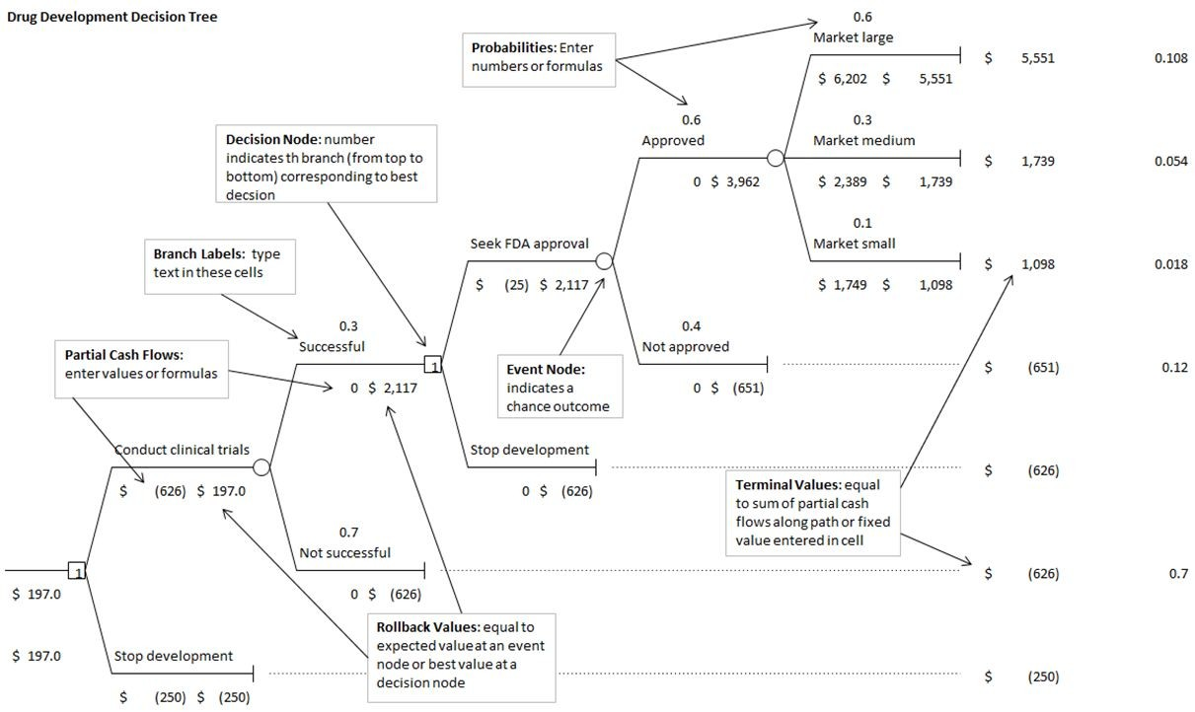

Let us assume that if market is large, payoff is lognormally distributed with a mean of $4,900 million and a standard deviation of $1,000 million; if market is medium, payoff is lognormally distributed with a mean of $2,500 million and a standard deviation of $500 million; and if market is small, payoff is normally distributed with a mean of $1,800 million and standard deviation of $200 million. Let us also assume that the cost of clinical trials is uncertain and estimates are modeled with a triangular distribution with a minimum of -$700 million, a most likely value of -$550 million, and a maximum of -$500 million. Use 10,000 trials and a random seed of 1.

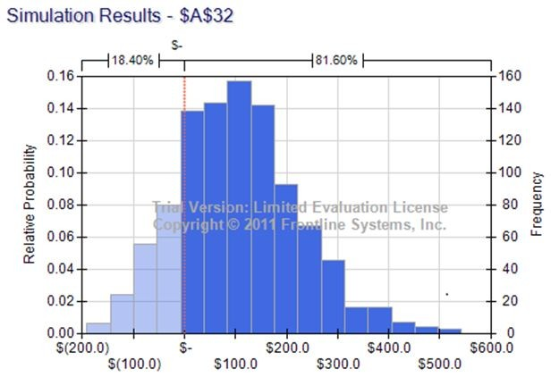

17) What is the value of mean obtained from the simulation results? [Hint: Choose the approximate value.]

A) $ 119.0

B) $ 116.1

C) $ 106.2

D) $ 94.4

Answer: C

Diff: 2

Blooms: Apply

AACSB: Analytic Skills

Topic: Decision Trees

LO1: Incorporate Monte Carlo simulation in decision trees.

LO2: Describe the major tools and criteria for decision making.

18) What is the value of standard deviation obtained from the simulation results? [Hint: Choose the approximate value.]

A) $ 119.1

B) $ 116.1

C) $ 105.7

D) $ 94.4

Answer: A

Diff: 2

Blooms: Apply

AACSB: Analytic Skills

Topic: Decision Trees

LO1: Incorporate Monte Carlo simulation in decision trees.

LO2: Describe the major tools and criteria for decision making.

19) What is the value of mode obtained from the simulation results? [Hint: Choose the approximate value.]

A) $ 119.0

B) $ 116.1

C) $ 105.7

D) $ 94.1

Answer: D

Diff: 2

Blooms: Apply

AACSB: Analytic Skills

Topic: Decision Trees

LO1: Incorporate Monte Carlo simulation in decision trees.

LO2: Describe the major tools and criteria for decision making.

20) What is the mean absolute deviation obtained from the simulation results? [Hint: Choose the approximate value.]

A) $ 119.0

B) $ 116.1

C) $ 105.7

D) $ 94.0

Answer: D

Diff: 2

Blooms: Apply

AACSB: Analytic Skills

Topic: Decision Trees

LO1: Incorporate Monte Carlo simulation in decision trees.

LO2: Describe the major tools and criteria for decision making.

21) What is the coefficient of variation obtained from the simulation results? [Hint: Choose the approximate value.]

A) 1.587

B) 1.122

C) 2.015

D) 1.890

Answer: B

Diff: 2

Blooms: Apply

AACSB: Analytic Skills

Topic: Decision Trees

LO1: Incorporate Monte Carlo simulation in decision trees.

LO2: Describe the major tools and criteria for decision making.

22) What is the probability that the drug will not reach the market? [Hint: Choose the approximate value.]

A) 0.95

B) 0.89

C) 0.77

D) 0.82

Answer: D

Diff: 1

Blooms: Apply

AACSB: Analytic Skills

Topic: Decision Trees

LO1: Incorporate Monte Carlo simulation in decision trees.

LO2: Describe the major tools and criteria for decision making.

Use the information below to answer the following question(s).

Below is a decision tree for the airline revenue management.

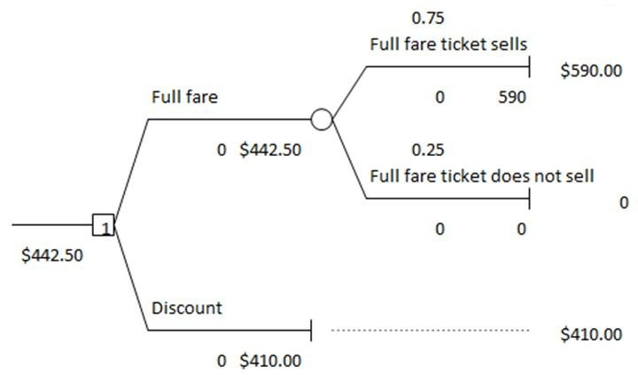

Create a one-way table and answer the following questions.

23) What is the expected value of the ticket when a discount is offered on the full fare? [Hint: Choose the approximate value.]

A) $ 442.50

B) $ 472.00

C) $ 410.00

D) $ 501.50

Answer: C

Diff: 2

Blooms: Apply

AACSB: Analytic Skills

Topic: Decision Trees

LO1: Incorporate Monte Carlo simulation in decision trees.

24) If the probability of selling the full-fare ticket is 0.80, what is the expected value of the ticket?

A) $ 442.50

B) $ 472.00

C) $ 501.50

D) $ 531.00

Answer: B

Diff: 2

Blooms: Apply

AACSB: Analytic Skills

Topic: Decision Trees

LO1: Incorporate Monte Carlo simulation in decision trees.

25) The expected value of perfect information (EVPI) is equal to the ________.

A) Expected Monetary Value (EMV) with perfect information minus the EMV without any information

B) EMV with perfect information divided by the EMV without any information

C) sum of the EMV with information and the EMV without any information

D) EMV without any information minus the EMV with perfect information

Answer: A

Diff: 1

Blooms: Apply

AACSB: Analytic Skills

Topic: The Value of Information

LO1: Compute the expected value of perfect information.

Use the below information to answer the following question(s).

Below is a payoff table with three mortgage options:

|  |  |  |  |
| --- | --- | --- | --- |
|  | **Outcome** | | |
| **Probability** | **0.6** | **0.3** | **0.1** |
| **Decision** | **Rates Rise** | **Rates Stable** | **Rates Fall** |
| **1-year ARM** | $66,645 | $43,650 | $38,560 |
| **3-year ARM** | $62,857 | $47,698 | $42,726 |
| **30-year fixed** | $52,276 | $52,276 | $52,276 |

26) What is the expected opportunity loss for the 1-year ARM?

A) $ 7,979.60

B) $ 3,959.40

C) $ 6,853.50

D) $ 8,621.40

Answer: D

Diff: 2

Blooms: Apply

AACSB: Analytic Skills

Topic: The Value of Information

LO1: Compute the expected value of perfect information.

27) What is the expected opportunity loss for the 3-year ARM?

A) $ 7,979.60

B) $ 3,959.40

C) $ 6,853.50

D) $ 8,621.40

Answer: A

Diff: 2

Blooms: Apply

AACSB: Analytic Skills

Topic: The Value of Information

LO1: Compute the expected value of perfect information.

28) What is the expected opportunity loss for the 30-year fixed decision?

A) $ 7,979.60

B) $ 3,959.40

C) $ 6,853.50

D) $ 8,621.40

Answer: B

Diff: 2

Blooms: Apply

AACSB: Analytic Skills

Topic: The Value of Information

LO1: Compute the expected value of perfect information.

29) The expected value of sample information (EVSI) is equal to the ________.

A) EMV without sample information divided by the EMV with sample information

B) EMV without sample information minus the EMV with sample information

C) sum of the EMV with sample information and the EMV without sample information

D) EMV with sample information minus the EMV without sample information

Answer: D

Diff: 1

Blooms: Remember

Topic: The Value of Information

LO1: Compute the expected value of perfect information.

Use the information below to answer the following question(s)

Misty Inc. launches a new range of perfumes for men and women. The probability of high consumer demand for the product is 0.6 and low consumer demand is 0.4. The probability of a favorable survey response given high consumer demand is 0.9 and the probability of a favorable survey response given low consumer demand is 0.2.

30) What is the likelihood for high demand knowing that the market report is favorable?

A) 84%

B) 90%

C) 87%

D) 80%

Answer: C

Diff: 2

Blooms: Apply

AACSB: Analytic Skills

Topic: The Value of Information

LO1: Incorporate sample information in decision trees and apply Bayes's rule to compute conditional probabilities.

LO2: Identify and apply the basic concepts and tools of probability

31) If the marketing report is unfavorable, what is the probability of low demand?

A) 84%

B) 90%

C) 87%

D) 80%

Answer: A

Diff: 2

Blooms: Apply

AACSB: Analytic Skills

Topic: The Value of Information

LO1: Incorporate sample information in decision trees and apply Bayes's rule to compute conditional probabilities.

LO2: Identify and apply the basic concepts and tools of probability

32) A children's welfare fundraiser involves selling one thousand $70 tickets to win a $20,000 grand prize. If the probability of winning is only 0.005, what is the expected payoff?

A) -$40

B) -$50

C) $30

D) $60

Answer: C

Diff: 1

Blooms: Apply

AACSB: Analytic Skills

Topic: Utility and Decision Making

LO1: Construct a utility function and use it to make a decision.

LO2: Describe the major tools and criteria for decision making.

33) Greg is indifferent between receiving $2,000, and taking a chance at $2,500 with probability 0.7 and losing $1200 with probability 0.5. What is the expected value of this gamble?

A) $ 1,150

B) $ 1,800

C) $ 1,460

D) $ 2,045

Answer: A

Diff: 1

Blooms: Apply

AACSB: Analytic Skills

Topic: Utility and Decision Making

LO1: Construct a utility function and use it to make a decision.

LO2: Describe the major tools and criteria for decision making.

Use the information below to answer the following question(s).

Below are four options for an investment decision.

|  |  |  |  |
| --- | --- | --- | --- |
| **Decision/Event** | **Rates Rise** | **Rates Stable** | **Rates Fall** |
| Bank CD | 0.80 | 0.80 | 0.80 |
| Bond fund | -0.75 | 0.86 | 1.50 |
| Index fund | 0.00 | 0.90 | 1.20 |
| Growth fund | -0.30 | 0.70 | 1.40 |

34) Which of the following is the average utility for the bond fund decision?

A) 1.18

B) 0.38

C) 0.54

D) 0.43

Answer: C

Diff: 1

Blooms: Apply

AACSB: Analytic Skills

Topic: Utility and Decision Making

LO1: Construct a utility function and use it to make a decision.

LO2: Describe the major tools and criteria for decision making.

35) Which of the following is the average utility for the index fund decision?

A) 1.05

B) 0.70

C) 0.60

D) 0.45

Answer: B

Diff: 1

Blooms: Apply

AACSB: Analytic Skills

Topic: Utility and Decision Making

LO1: Construct a utility function and use it to make a decision.

LO2: Describe the major tools and criteria for decision making.

36) Identify the average utility for the growth fund decision.

A) 1.05

B) 0.70

C) 0.20

D) 0.60

Answer: D

Diff: 1

Blooms: Apply

AACSB: Analytic Skills

Topic: Utility and Decision Making

LO1: Construct a utility function and use it to make a decision.

LO2: Describe the major tools and criteria for decision making.

37) Based on the average utility, which of the following is considered the best decision?

A) Bank CD

B) Bond fund

C) Index fund

D) Growth fund

Answer: A

Diff: 1

Blooms: Apply

AACSB: Analytic Skills

Topic: Utility and Decision Making

LO1: Construct a utility function and use it to make a decision.

LO2: Describe the major tools and criteria for decision making.

38) Based on the average utility, which of the following is considered the worst decision?

A) Bank CD

B) Bond fund

C) Index fund

D) Growth fund

Answer: B

Diff: 1

Blooms: Apply

AACSB: Analytic Skills

Topic: Utility and Decision Making

LO1: Construct a utility function and use it to make a decision.

LO2: Describe the major tools and criteria for decision making.

39) Which of the following formulas is used to determine the exponential utility function?

A) *U*(*x*) = 1 + *e*—*x*/*R*

B) *U*(*x*) = 1× *ex*/*R*

C) *U*(*x*) = 1/ *exR*

D) *U*(*x*) = 1 — *e*—*x*/*R*

Answer: D

Diff: 1

Blooms: Remember

Topic: Utility and Decision Making

LO1: Construct a utility function and use it to make a decision.

LO2: Describe the major tools and criteria for decision making.

40) If the payoff is $2200 and *R* is equal to $500, what is the utility function?

A) 0.9877

B) 0.6819

C) 0.7645

D) 0.4502

Answer: A

Diff: 1

Blooms: Apply

AACSB: Analytic Skills

Topic: Utility and Decision Making

LO1: Construct a utility function and use it to make a decision.

LO2: Describe the major tools and criteria for decision making.

41) A payoff table is a matrix whose rows correspond to events and whose columns correspond to decisions.

Answer: FALSE

Diff: 1

Blooms: Remember

Topic: Making Decisions with Uncertain Information

LO1: Construct a payoff table for a decision situation.

LO2: Describe the major tools and criteria for decision making.

42) For the average payoff strategy, the decision with the best average payoff is chosen.

Answer: TRUE

Diff: 1

Blooms: Remember

Topic: Making Decisions with Uncertain Information

LO1: Construct a payoff table for a decision situation.

LO2: Describe the major tools and criteria for decision making.

43) In a minimin strategy, the decision which minimizes the minimum payoff is chosen.

Answer: TRUE

Diff: 1

Blooms: Remember

Topic: Making Decisions with Uncertain Information

LO1: Apply average, aggressive, conservative, and opportunity-loss decision strategies for problems involving minimization and maximization objectives.

LO2: Describe the major tools and criteria for decision making.

44) The average payoff strategy weights the likelihood that the actual outcomes can occur.

Answer: FALSE

Diff: 1

Blooms: Remember

Topic: Making Decisions with Uncertain Information

LO1: Apply average, aggressive, conservative, and opportunity-loss decision strategies for problems involving minimization and maximization objectives.

LO2: Describe the major tools and criteria for decision making.

45) An outcome over which the decision maker has complete control is called an event node.

Answer: FALSE

Diff: 1

Blooms: Remember

Topic: Decision Trees

LO1: Use Risk Solver Platform to construct decision trees.

LO2: Describe the major tools and criteria for decision making.

46) What are the three elements required to characterize decisions with uncertain consequences?

Answer: Many decisions involve a choice from among a small set of alternatives with uncertain consequences. Such decisions can be characterized by defining three things:

(1) the decision alternatives

(2) the outcomes that may occur once a decision is made

(3) the payoff associated with each decision and outcome

Diff: 1

Blooms: Remember

Topic: Making Decisions with Uncertain Information

LO1: List the three elements needed to characterize decisions with uncertain consequences.

LO2: Describe the major tools and criteria for decision making.

47) What are the differences between an aggressive strategy and a conservative strategy?

Answer: An aggressive decision maker might seek the option that holds the promise of minimizing the potential loss. For a minimization objective, this strategy is also often called a minimin strategy, that is, the decision that minimizes the minimum payoff is chosen. Aggressive decision makers are often called speculators, particularly in financial arenas because they increase their exposure to risk in hopes of increasing their return. A conservative decision maker, on the other hand, might take a more pessimistic attitude. Such a strategy is also known as a minimax strategybecause we seek the decision that corresponds to the minimum value of the largest cost. Conservative decision makers are often called risk averseand are willing to forgo potential returns in order to reduce their exposure to risk.

Diff: 2

Blooms: Remember

Topic: Making Decisions with Uncertain Information

LO1: Apply average, aggressive, conservative, and opportunity-loss decision strategies for problems involving minimization and maximization objectives.

LO2: Describe the major tools and criteria for decision making.

48) Describe the steps involved in the construction of a decision tree.

Answer: A useful approach to structuring a decision problem involving uncertainty is to use a graphical model called a decision tree. Decision trees consist of a set of nodes and branches. Nodes are points in time at which events take place. The event can be a selection of a decision from among several alternatives, represented by a decision node, or an outcome over which the decision maker has no control, an event node.

Diff: 1

Blooms: Remember

Topic: Decision Trees

LO1: Use Risk Solver Platform to construct decision trees.

LO2: Describe the major tools and criteria for decision making.

49) What is the expected value of perfect information?

Answer: The expected value of perfect information (EVPI) is the EMV with perfect information minus the EMV without any information. It represents the most a person is willing to pay for perfect information. Perfect information states with certainty what outcome will occur.

Diff: 1

Blooms: Remember

Topic: The Value of Information

LO1: Compute the expected value of perfect information.

50) What is the expected value of sample information?

Answer: The expected value of sample information (EVSI) is the EMV with sample information minus the EMV without sample information. It represents the most a person is willing to pay for the sample information. Sample information is the result of conducting some type of experiment, such as market research study.

Diff: 1

Blooms: Remember

Topic: The Value of Information

LO1: Compute the expected value of perfect information.